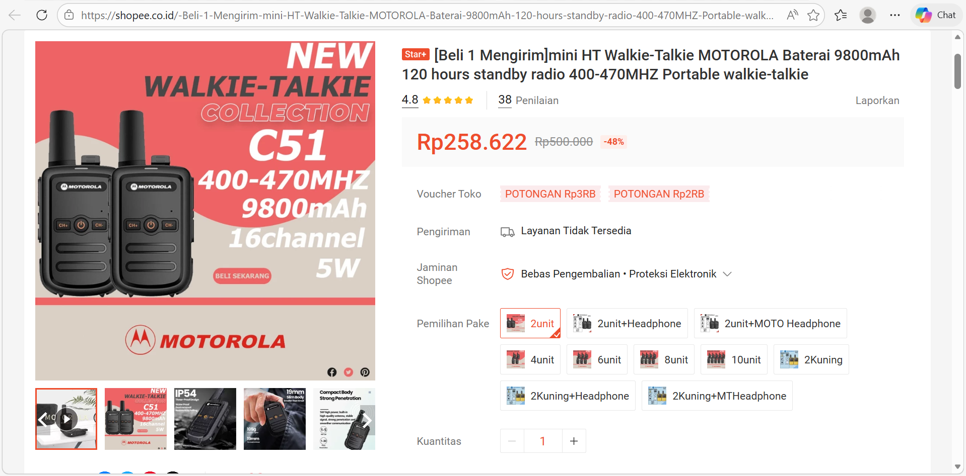
Jual [Beli 1 Mengirim]mini HT Walkie-Talkie MOTOROLA Baterai 9800mAh 120 hours standby radio 400-470MHZ Portable walkie-talkie | Shopee Indonesia

Kebutuhan untuk unloading dan instalasi SHP: 6
Lokasi | Kebutuhan HT
Area Luar | 2
Lantai 1 | 1
Lantai 2 | 1
Biovac | 2
Total | 6

Kebutuhan Operasional: 16
Departemen | Kebutuhan HT
Produksi  (clean room) | 4
QC  (clean room) | 3
Logistik | 3
Engineer | 4
GA | 2
Total | 16

