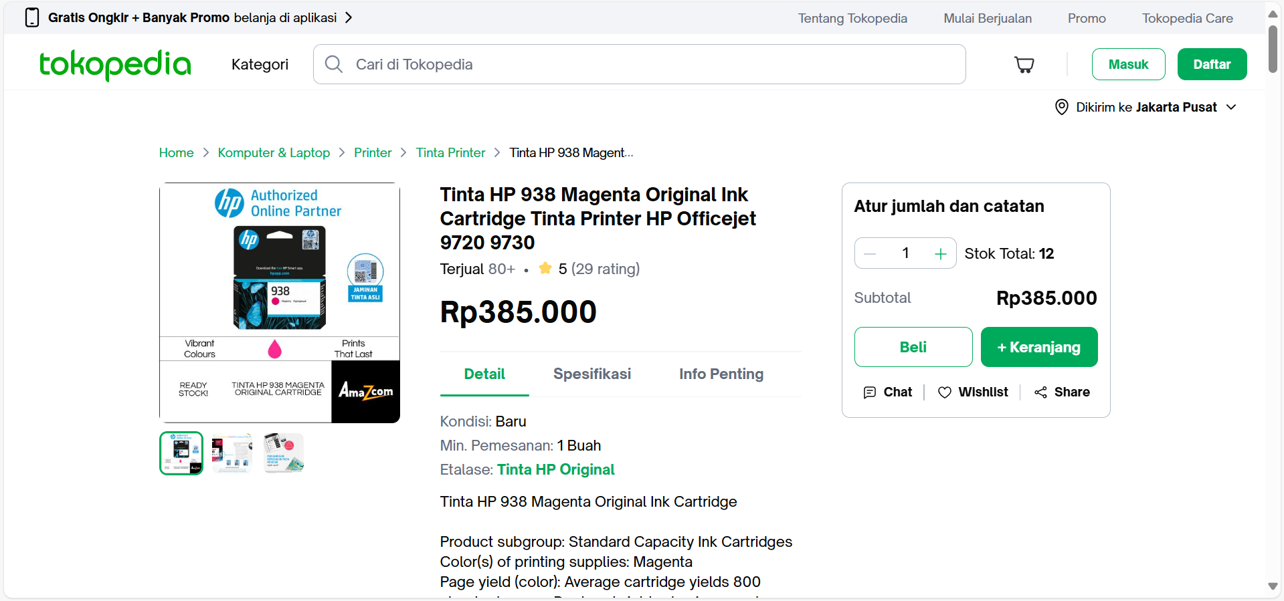
Jual Tinta HP 938 Magenta Original Ink Cartridge Tinta Printer HP Officejet 9720 9730 - Jakarta Pusat - Amazcom | Tokopedia

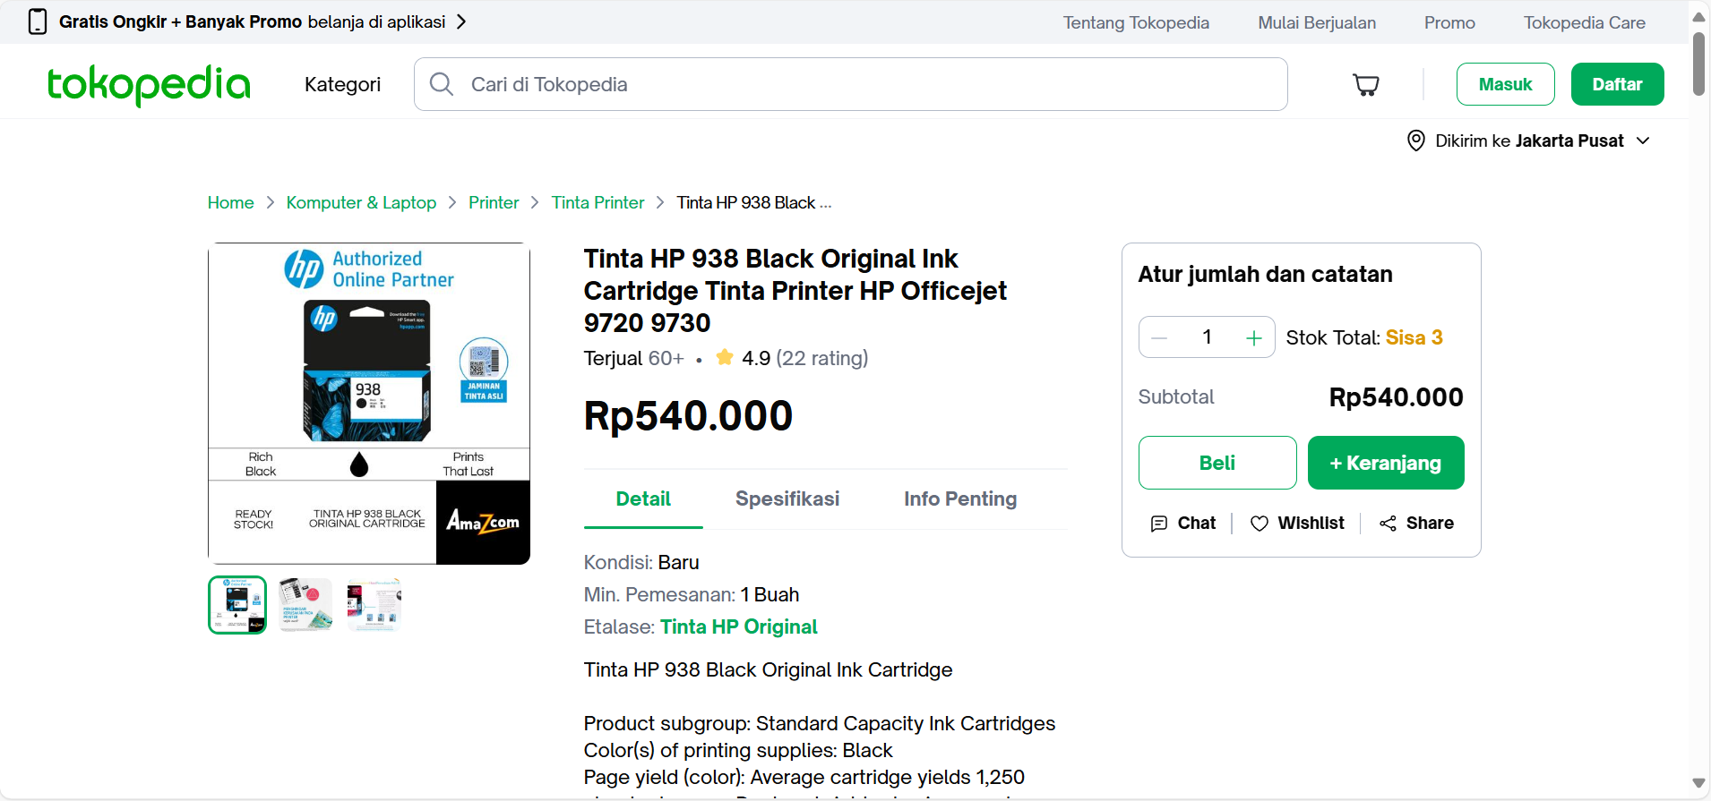
Promo Tinta HP 938 Black Original Ink Cartridge Tinta Printer HP Officejet 9720 9730 Cicil 0% 3x - Jakarta Pusat - Amazcom | Tokopedia
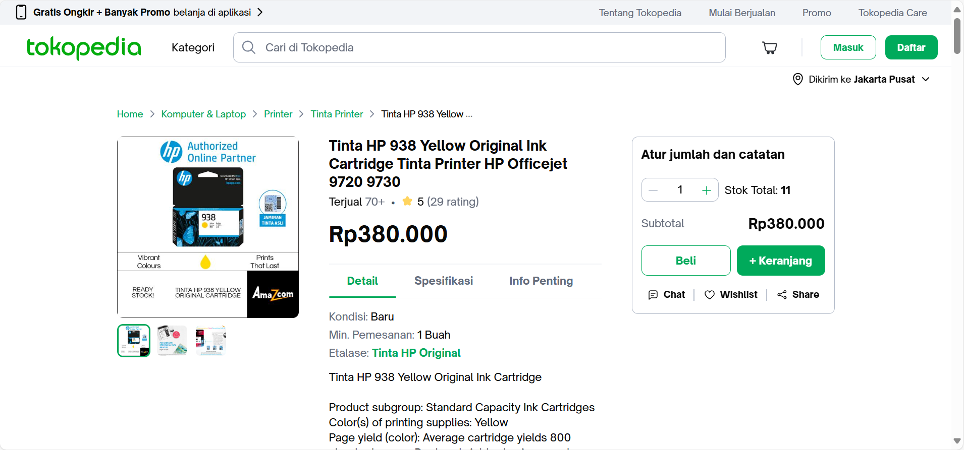
Jual Tinta HP 938 Yellow Original Ink Cartridge Tinta Printer HP Officejet 9720 9730 - Jakarta Pusat - Amazcom | Tokopedia
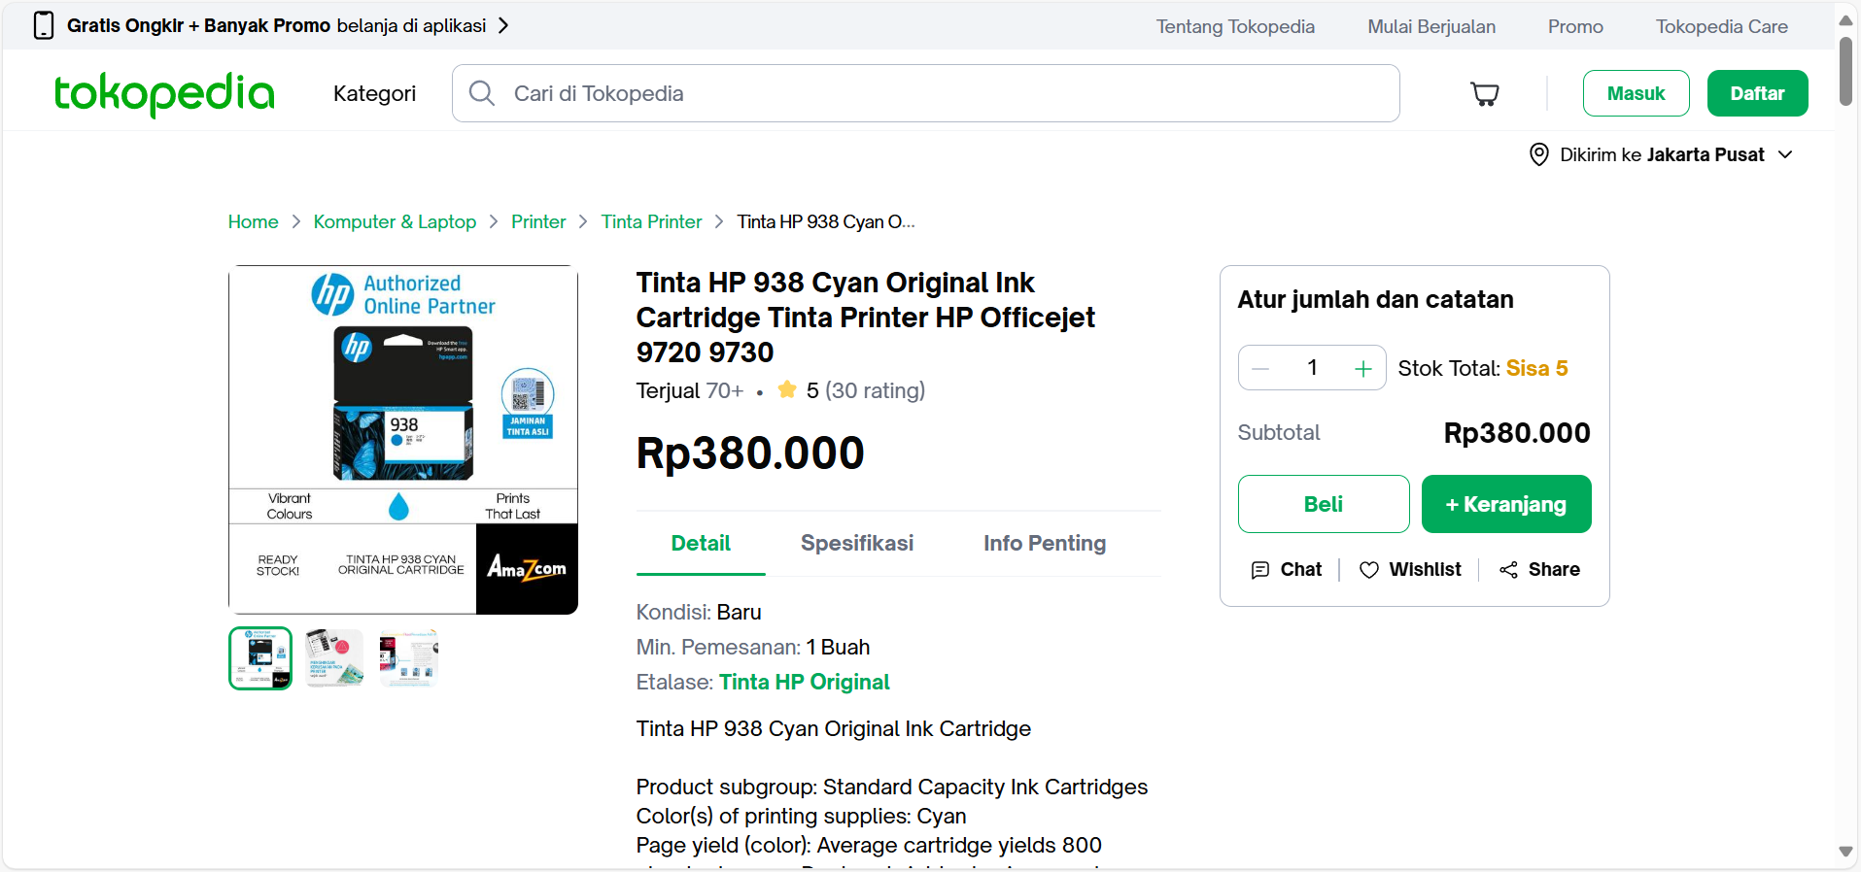
Jual Tinta HP 938 Cyan Original Ink Cartridge Tinta Printer HP Officejet 9720 9730 - Jakarta Pusat - Amazcom | Tokopedia

