Cartridge hp 2590 original 100% W3T10B
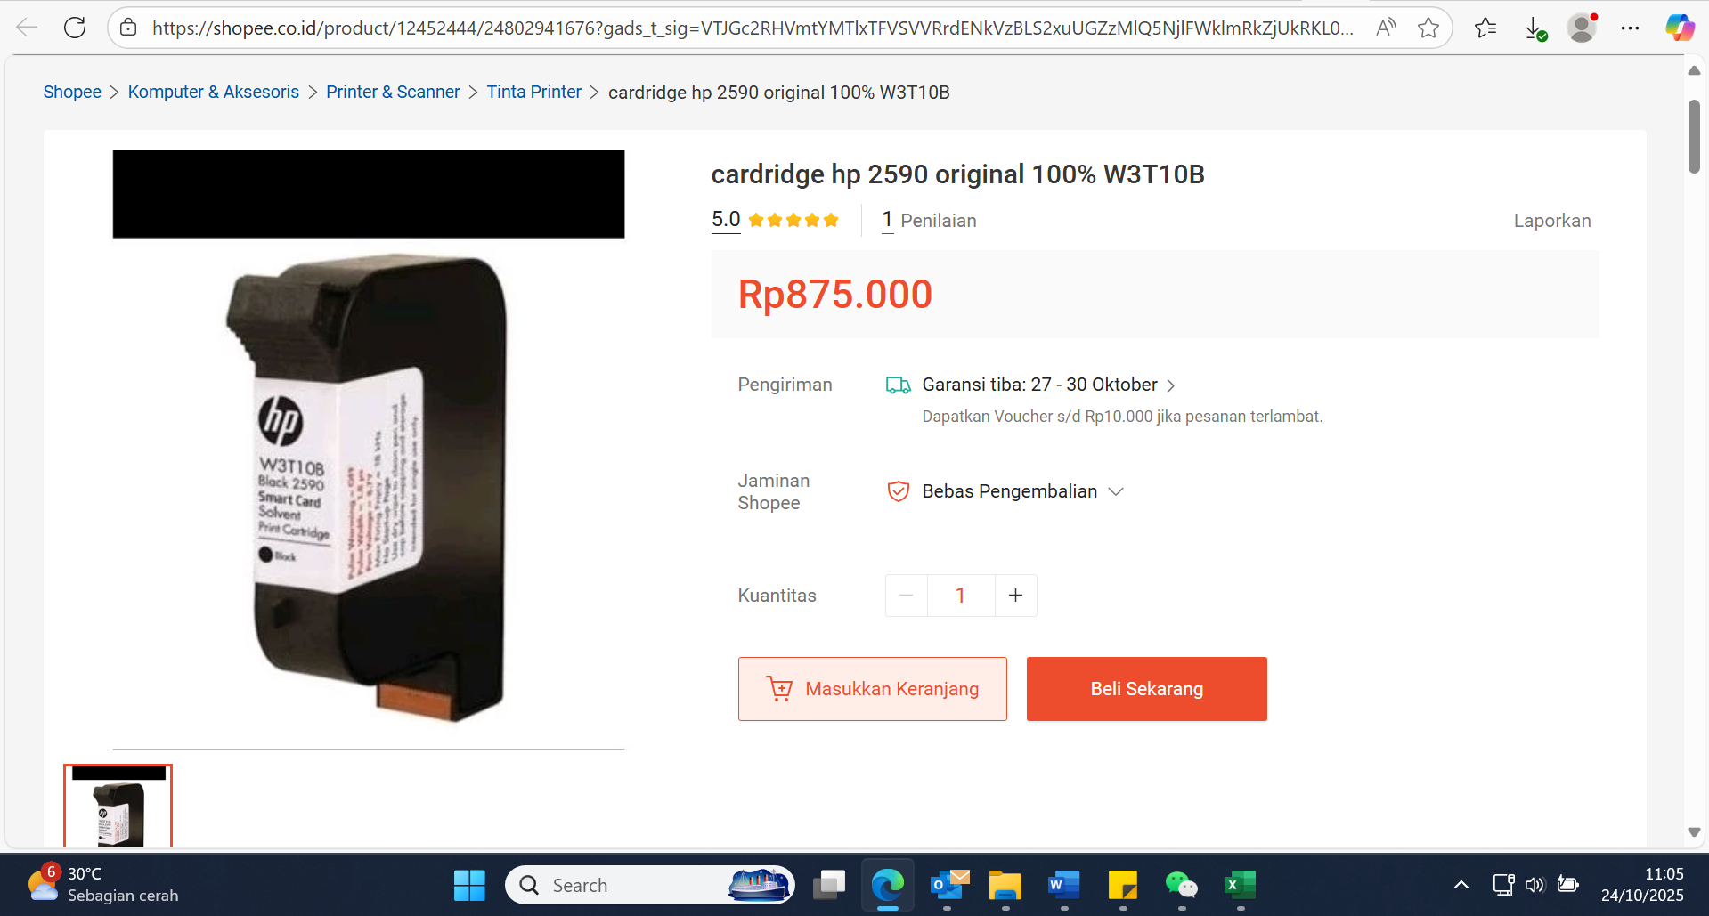
Jual cardridge hp 2590 original 100% W3T10B | Shopee Indonesia

